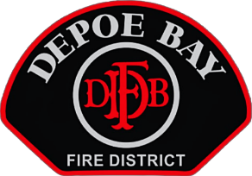

DEPOE BAY RURAL FIRE PROTECTION DISTRICT
BOARD OF DIRECTORS SPECIAL BOARD MEETING
Thursday, July 16, 2026
3 P.M.
Station 22 • 6445 Gleneden Beach Loop – Gleneden Beach, OR.

***AGENDA***

CALL TO ORDER – Pledge of Allegiance

ROLL CALL

- ITEMS NOT ON THE AGENDA – (Open to Public, Board, and Staff Participation)

- RESOLUTION 2026-03 (RESOLUTION #2026-03 Transferring from General Fund Line Items To a General Fund Line Item)

PUBLIC COMMENTS AND/OR QUESTIONS

AGENDA SUGGESTIONS – OPEN

ADJOURN

Upcoming Meetings:

Regular Board Meeting Tuesday, August 11, 2026, at 3:00 pm at:
Gleneden Beach Fire Station 22 - 6445 Gleneden Beach Loop, Gleneden Beach, OR 97388

Depoe Bay Fire District - Board of Directors Meeting
Please join my meeting from your computer, tablet, or smartphone.
https://global.gotomeeting.com/join/833057797
You can also dial in using your phone.
United States: +1 (872) 240-3311
Access Code: 833-057-797
New to GoToMeeting? Get the app now and be ready when your first meeting starts: https://global.gotomeeting.com/install/833057797

